Instituto Superior de Educación Normal del Estado de Colima
“Prof. Gregorio Torres Quintero”


Modalidad de titulación: Informe de Prácticas

Licenciatura en Enseñanza y Aprendizaje del Inglés en Secundaria

“TITULO” Enforcement PPP methodology to learn English grammar in EFL classroom “

Nombre de la alumna: Valeria Samantha Montelón Montes

Nombre del asesor: Mtra. Zaida Nohemí Benavides Romero

Generación 2020-2024
Agradecimientos

Agradezco a mi asesora
La maestra Zaida Benavides por haberme acompañado durante todo este trayecto, una de las mejores maestras que he tenido y a lo largo de estos años de la carrera siempre ha sido un ejemplo a seguir para mí, gracias maestra por todas sus enseñanzas, su apoyo, confianza y paciencia.

A mi Maestra Titular
La maestra Paola quien fue de apoyo indispensable para el desarrollo de mis practicas en la Escuela secundaria, gracias maestra por darme la oportunidad de aprender de usted y de sus estrategias.

A mi grupo de practica
Le doy gracias a los alumnos de 2ºB por permitirme ser su maestra durante este largo periodo, aprendí mucho de ellos, fueron momentos muy bonitos los que pasé a su lado, entre risas y algunos regaños me dieron la oportunidad de conocerlos a cada uno de ellos, dejaron una bonita huella en mi vida, gracias chicos por todo.

Dedicatoria
A mi familia
Gracias a mis padres y a mi hermano por ser el pilar de mi vida, gracias por haberme acompañado y ser mis guías durante cuatro años de este proceso, brindándome su apoyo, cariño y amor incondicional en cada paso que daba, siempre impulsándome a ser mejor personal y como profesionalmente.

Resumen
En el siguiente informe de práctica presentará una investigación referente a las enseñanzas del inglés a nivel secundaria. Los alumnos de segundo grado en la escuela secundaria Alberto Isaac ahumada T.M tienen dificultades para entender los temas de gramática inglesa. Es por eso que el objetivo principal de esta investigación es mejorar el aprendizaje de la gramática inglesa a través de la metodología Presentación práctica and producción en los estudiantes de segundo grado en el nivel secundaria en la materia de lengua extranjera inglés.
Después del análisis del contexto y nivel de inglés en los grupos de segundos participantes; se eligió al grupo más bajo en rendimiento académico para trabajar con él y promover el aprendizaje gramatical de la lengua extranjera. Aplicando la metodología PPP enfocada en fomentar y desarrollar la habilidad de la escritura mediante la formación de oraciones relacionadas con temas gramaticales.
Durante la aplicación de esta metodología se aplicaron diversas estrategias y actividades guiadas donde los alumnos tuvieron la oportunidad de reforzar la gramática inglesa de diferentes temas. Al finalizar la aplicación se llevaron a cabo varios instrumentos de evaluación para medir el nivel de logro de los alumnos. Dando como resultado un aumento en las calificaciones de los alumnos, así como su conocimiento de los temas gramaticales y la redacción de oraciones en los temas vistos durante las clases intencionadas.
Concluyendo que esta metodología apoya a los alumnos de bajo nivel de inglés en reforzar sus conocimientos de la lengua inglesa.
Palabras clave: aprendizaje, metodología PPP, gramática inglesa

Abstract
In the following practice report, an investigation will be presented regarding the teaching of English at the secondary level. Second grade students at Alberto Isaac Ahumada T.M High School have difficulty understanding English grammar topics. That is why the main objective of this research is to improve the learning of English grammar through the Presentation Practice and Production methodology in second grade students at the secondary level in the subject of English foreign language.
After the analysis of the context and level of English in the groups of second participants; the group with the lowest academic performance was chosen to work with and promote grammatical learning of the foreign language. Applying the PPP methodology focused on promoting and developing writing skills through the formation of sentences related to grammatical topics.
During the application of this methodology, various strategies and guided activities were applied where students had the opportunity to reinforce English grammar on different topics. At the end of the application, several evaluation instruments were carried out to measure the level of achievement of the students. Resulting in an increase in the students' grades, as well as their knowledge of grammatical topics and sentence writing on the topics seen during the intentional classes.
Concluding that this methodology supports students with a low level of English in reinforcing their knowledge of the English language.
Keywords: learning, PPP methodology, English grammar.

Index
Content
Introduction………………………………………………………………………………1
Chapter I
Context………………………………………………………………….……….2
General Context ……………………………………………… …………….3
1.12 School Context ………………………………………………………..4
1.13 Social Context ………………………………………………………….6
1.14 Familiar Context ………………………………………………………..7
1.15 Classroom Context …………………………………………………….8
1.2 Justification ………………………………………………………………11
1.2.1 Objectives ………………………………………………………………13
Chapter II
Action Plan …………………………………………………………………………..14
2.1 Intention……………………………………………………………………… 17
2.1.2 Goals……………………………………………………………………………19
2.1.3 Relationship topic-competences …………………………………………….…………………………………………….20
2.2 Planning …………………………………………………………………………………………...22
2.2.1 Diagnostic …………………………………………………………………………………………...23
2.2.2 Objectives ……………………………………………………………………………………………24
2.2.3 The group of study ……………………………………………………………… 25
2.2.4 Theoretical Foundation ……………………………………………………….....26
2.2.5 Action Plan ……………………………………………………………………… ..29
2.2 .6 Observations and Evaluation …………………………………………………..39
2.2.7 Reflection ………………………………………………………………………….43
Chapter III ………………………………………………………………………………..44
3.1 Theorization ………………………………………………………………………...44
3.2 Conclusions
3.3 Recommendations ………………………………………….............................47

References …………………………………………………………………………………55
Appendices …………………………………………………………………………. ……60

Table of contents
Pag
Figure 1 Geographic location for the school Alberto Isaac Ahumada T.M……3
Figure 2 School diagram ………………………………………………………………...6
Figure 3 Classroom ………………………………………………………………………10
Figure 4 Smith Cycle ………………………………………………………………………15
Figure 5 PPP methodology ………………………………………………………………17
Pag
Figure 6 Results …………………………………………………………………….23
Figure 7 Learning Channel Test …………………………………………………25
Figure 8 Action Plan 1 ……………………………………………………………..32
Figure 9 Results of Action plan ………………………………………………….32
Figure 10 Reflection Cycle 1 ………………………………………………………36
Figure 11 Action Plan 2……………………………………………………………..36
Figure 12 Results Cycle 2…………………………………………………………...37
Figure 13 Evaluation Cycle 2 ……………………………………………………….38
Figure 14 Evaluation List ……………………………………………………………39
Figure 15 Lesson Plan ……………………………………………………………….40
Figure 16 Results of Quiz Application ……………………………………………42
Figure 17 Final Grades ………………………………………………………………...44

INTRODUCTION
Teaching grammar in the English foreign language classrooms is an essential part of the learning of tenses and phrases. According some authors, it is a great tool to enhance the English language. In the following report we will present Th presenting- practice and production methodology applied to high school students where we seek to implement the learning of grammar, in the foreign language.
The main feature of this research is how the students with low level of English can improve their knowledge of grammar in the EFL classroom. This begins with the observation and analysis of the context where students develop and learn a new language. Based on this, a methodology is sought that helps students learn to form sentences, become competent of grammatical topics and thus promote meaningful learning.
With the title “Enforcement PPP methodology to teach English grammar in EFL classroom”. This research seeks to modify the way of teaching the second language in secondary school. It takes into account the knowledge of students and their level of English learned in their first school years. Based on this data begin to implement the methodology that will improve their language skills.
Additionally, the school and social context of the students of the secondary school “Alberto Isaac Ahumada” T.M. were other important elements in the realization of this project. Seeking to improve the knowledge of the English language in the students was the problem of study in the report.
In the same way, the theoretical research for this report helped me learn what the authors have researched about the strategies that can be applied with low-level English learners. At the same time, this allowed me to identify the main causes and disadvantages of why at these levels of basic education students do not arrive with the expected language.
This report is divided into 3 chapters where the information obtained and analyzed during the process is reflected. In chapter I we begin to investigate the contexts: social, school and classroom, based on these we start with the analysis of each one of them and their different factors that affect it. Knowing the students' context help us guide the research done during the practice.
Furthermore, in the chapter I can we find the selection of the competences which we will work for the improvement of the chosen problem is made, as well as the writing of the objectives which we want to achieve during the implementation of the methodology.
And then, in chapter 2, during the writing of this chapter, some quotes about the authors investigated are presented. This referring to the importance of grammar in the learning of the foreign language. It is mentioned authors such as Harmer, Thornbury, and others, who were important in conducting this research. In addition are presented the action plan, the strategies and activities based on the PPP methodology which was implemented in this work. According the characteristics of the study group.
Finally, in chapter 3, theorization is presented, where I show the review of the theory based on the methodology chosen for this report. As well as the conclusions and recommendations made after having applied the different activities of the proposed methodology.
To sum up, it is important that as teachers, we begin generating a change from the way of teaching to provide our students a new and better way of learning.

CHAPTER I
CONTEXT

1.1General context
The Secondary School "Alberto Isaac Ahumada " T.M is located in the municipality of Colima, in the streets Arnoldo Vogel, C. Arnoldo Voguel Carrillo Sn, Burócratas, 28048 Colima, Col., is located it is just a few streets away from the avenue.
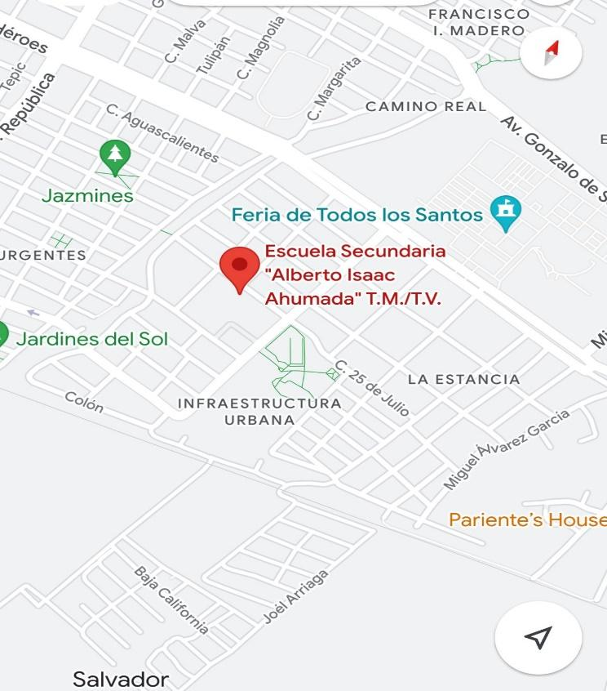

Figure 1: Geographic location for the school Alberto Isaac Ahumada T.M
The school has two schedules: morning and afternoon, I attend my practices in the morning schedule which is from 7:00 am to 1:00 pm, and the afternoon schedule is from 1:00 to 7:00pm. the work center password is 06DES00191.

1.1.2 school context
The school is formed principally by the management staff, the director and the assistant director who are always present and do their job very well, there is also a service area such as social work where there are 4 secretaries, as well as the personal secretary of the management area.
The school has a cleaning staff of 3 people, one per area, as well as a psychology staff, and a prefecture where there are 2 people supporting different grades of the school, and of course the teaching staff, which is complete in each area, there are about 41 teachers and 20 for personal administration.
The teachers provide the 7 corresponding subjects and there are also music and dance workshops as part of their extracurricular activities, like the technology workshops are also taught and the school choir participates in events at the state level.
The school is small, has 5 classrooms per grade from A to E, in each, in each classroom there are about 25-30 students, in their classrooms they have access to a projector, a blackboard and internet for the whole school, which are very good tools that help to teach a good class.
The school has a library, two recreation areas, a multimedia room where technology classes are taken, meetings are held, etc., as well as a well-equipped laboratory and restrooms for boys and girls.
They also have a cafeteria service which is very well equipped with accessible prices and a variety of food for students and staff, another service offered by the school is a small stationery store where students can find basic material for their classes.
The staff is very friendly and everyone is always in their area giving their functions, there are not many students, we are talking about 25-30 students per classroom, so the working environment is pleasant and the students can be placed quickly.
It is a good school, although the social and cultural context is not very helpful for the performance of the students.

1.1.3 Social Context
In the area where the school is located there are many factors that contribute and affect the development and performance of students in the school., we are talking about an area where the socioeconomic level is relatively low, there is crime, drug selling points, shootings, etc.
In the surrounding area there are many neighbors but unfortunately it is a low-level community, there are vacant lots, animals in street situation, graffitied walls, and drug addicts or people with mental problems that roam around the school.
Now talking about the students, it can be said that they also have a low socioeconomic level, in my practices I have been able to notice different situations such as: students come from dysfunctional families where there is no father or mother, even some live with their grandparents, tutors, etc., also work to bring money home and support inclusive that same money is used for their studies, this affects their performance in school.
In other situations, I also mentioned that many times students ask teachers for support for transportation, food, etc. because they do not have this support at home.
Many of them live situations at home that prevent them from continuing with their studies, others continue them but with many difficulties.
The lack of attention and affection that they live at home is also a factor that affects them at school, since due to this situation they take refuge in classmates or teachers to feel this attention or affection that they do not receive, this type of students is involved in situations such as wanting attention, being very restless, being very rude children, etc., for them the school is like their safe place and they drain their energy and emotions in different ways.
Also, many of these students begin to deal with their problems at home looking for alternatives such as drugs, alcoholism, etc. They smoke, drink, drink to forget their problems or because they also see this at home, another critical situation that occurs a lot are pregnancies at an early age, we have had cases of several students in this situation, unfortunately many of them simply leave school.
Another situation is the lack of resources they have, for example most of the students do not have access to internet, they do not have a cell phone, computer where they can do their homework, some of them often do not bring the material to work in class because they cannot afford it.
Faced with all these situations, measures have been taken to help students, talks have been implemented, scholarship applications, accessibility for food, etc. Unfortunately, the situation goes beyond that, it has not been possible to eliminate this situation, but it has been gradually decreasing.

1.1.4 Familiar Context
The school could not provide us with more personal information about family situations of the students that trigger their behavior at school, so we cannot discuss the information in detail. About the family context of the students at school I said that parents are not very involved in the school, there is not the required importance in the education of their children, as I mentioned before most students come from dysfunctional families where both members are rarely present, in this case the student grows up in a difficult environment that limits them to many things and that exposes them to various situations such as the need to work to support their family.
Another thing that I think is important to mention is the fact that students also grow up in a violent environment, we are talking about physical and emotional violence that affects and is reflected in their development as adolescents, these same behaviors are also reflected in the classroom, in the relationship with their classmates, with their teachers, etc.
For this type of situation, the school has trained personnel to assist students, if necessary, the social worker and the psychologist are always attentive to the students, unfortunately, the school can't do much for them, since the educational rules do not allow to link with the student beyond the school context.
Students live many critical situations outside the school, we do what we can to intervene, unfortunately in this type of situation where there is no interest in supporting the student from the parent, there is not much to do. as well as tutors and teachers also attend these issues but they don’t participate giving them a solution.
In the school there is a parents' society, which is in charge of getting involved in school events, meetings, important matters, etc.
Unfortunately, their participation here is very scarce, the parents do not show enough interest in the student's performance, they do not attend the meetings, they are not involved as a parents' society, therefore this role is taken by the group tutors.

1.1.5 Classroom context
I am currently working with 5 second grade English “A to E” of which I was analyzing and observing their characteristics during my days of practice and observation, I analyzed which of them was more feasible to apply my methodology.
I was observing these groups for a few days, all of them and took into account many factors in order to develop my project with only one of them, finally when I finished observing I had a group chosen, however it was not completely adapted to what I wanted
to apply, so during my internship I could notice in a better way who would be my study group and I chose 2B.
One of the factors that caught my attention in this group was their low level of learning in English, I was working with them on some topics, however even changing the strategy it was difficult for them to understand something "simple", I realized that there were children with learning barriers, with problems of indiscipline, lagging behind in school, etc.
This group has 29 students, many of these students have problems such as learning barriers, problems of indiscipline, among others, this result was verified with a diagnostic test of which 50% of the students obtained 0 as a result, we also applied a test of learning channels which is not accessible because it is information that the school cannot provide us.
The problem that calls my attention is the low level they present in the subject of English, these students are very participative but it is difficult for them to understand the topics, that is why I chose 2B in order to solve this problem they represent.
One of the things I noticed during my weeks of observation and practice was that they are not a bad group, it is clear that they present a problem of student lag , one of the things that interested me the most about this group is their interest in their grades and their great enthusiasm to participate, it was clear that they did not have a good knowledge of the English language, however they were interested in learning, which caught my attention and of course all these factors were feasible to be able to apply my methodology.
Their behavioral behaviors were not that bad, they showed some indiscipline but nothing that could not be corrected with a classroom regulation, many of these factors caught my attention and that is why i chose this group to work with them in my report for my degree work.

1.2 Justification
I chose to apply PPP methodology because it is a very favorable method for learning a second language through teacher-controlled activities, didactic and practice activities taking into account real context situations.
I am doing this research because the 2nd B group has a low level of second language learning, however they have many favorable aspects to the methodology. and according to Jeremy Harmer (2009), the PPP is a method that is widely used in teaching simple language at lower levels, such as the students are very participative, they like to do dynamic activities and they learn very fast, that is why I chose the second-grade group to teach them grammar through the PPP methodology.
Taking into account my two competencies: professional and disciplinary on which I based myself to support me in the way I want to achieve my goals.
The professional competence: "Use knowledge of the English language and its didactics to make transpositions according to the characteristics and context of the students in order to address the curricular contents of the current curricula" I chose this one because the methodology tells us that the teacher presents his language which in this case would be English as the target language; so that in this way the students practice the new linguistic elements, also take into account that my methodology includes the didactics through activities that the teacher adjusts to the context of the students in order to achieve the expected learning.
The disciplinary competence: "Disciplinary Competences
"Apply the second language teaching approach for the design and evaluation of learning situations at the various levels of the national education system " in this case I will apply it in the second-grade secondary level, the learning situations refers to the various activities that I will use to carry out this process focusing on a grammatical learning of the second language, and if we talk about evaluation can be reflected at the end by quizzes or exams.
This methodology will help students to learn grammar by means of different activities divided in 3 steps: the presentation of the subject by the teacher, the practice together with the students through controlled exercises and finally the production of the exercises, according to Jeremy Harmer, Longman (1998), Scott Thornbury, (Longman 1999) in the book “how to teach grammar”.
At the junior high school level, English plays an important role in the learning of a second language for adolescents who are still at a developmental stage, where it is still possible for them to acquire meaningful knowledge.
As Krashen (1981) says, distinguishing between acquisition and learning, "a second language is acquired naturally and unconsciously". To contribute to the teaching of English, the methodology that twice seems to me a very good example, since we should twice that for students who have not had a complete education as such, their level of English is low and we as English teachers have to start from scratch to begin to build in each of them a learning, but in what way?
Harmer's methodology suggests that we contextualize what we want to teach, which is very important because all students learn differently and if we adjust to their context, we make them pay attention and even the class becomes interesting and fun, we seek first of all to make clear the meaning of the topic we are going to work on, In this stage the students learn a lot because through examples such as sentences, word games, etc. they acquire knowledge and finally for the third stage, which is the production, the student already has a very good knowledge of what is going to be achieved.
The student does not have to think too much, and produces the product in a very natural way since it was previously practiced and analyzed, it seems important to me to add this methodology, we would make English more entertaining and easier to learn for the students.

1.3 Objectives
Title: “Enforcement PPP methodology to learn English grammar in EFL classroom”
Research problem: The second-grade students have difficulties to understand the grammar topics
Research question: How can I teach grammar to second grade students?
General objective: Improve the learning of the English grammar through the PPP methodology in the second-grade students in the ESL classroom.
Specific objectives:
Present innovative presentations to explain the English grammar topic to the second-grade students.
Engage students in dynamic and controlled activities to reinforce understanding of presented concepts.
Assess understanding through a short written exercise where students incorporate the learned concepts.

CHAPTER II
ACTION PLAN

2.1 Intention
The English language has always been of vital importance as it opens doors to many opportunities, is essential as a subject in schools from basic to higher education, however it is not given the importance it needs in the sense of the educational system.
The progress and impact that this language has had since it is the most spoken language in the world, it is required for many jobs and in the sense of education it is implemented as a subject from elementary school to college, “The use of a foreign language, with an emphasis on English, has gone from being a privilege to a foreign language necessity", Biava and Safe (2010). As mentioned above, English is the most spoken language in the world, followed by Chinese and Hindi, for this globalized world we must always be updated and Mexico as an outgoing country should give importance to implement it as essential since we are a country with a lot of connection to the United States, for this reason, the mastery of the language should be established in the educational levels from basic education to higher education "Mexico is a country that has not emphasized the mastery of the English language therefore it does not have a high level of English proficiency" (Cronquist and Fiszbein, 2017). In order for students to reach the expected language level at the end of their studies, it must be practiced from the beginning of their education, however, our country has not prioritized the use of English as a foreign language.
Even that we are in a new era where our education should advance, English is still a language that is not so important for our country despite the fact that we are on the border with foreign countries as United States and Canada, and yet a good teaching system has not been established.
In the basic education schools (public) in which I have been giving my professional practices I could notice that the English language is not established in such a way that the students learn it , Based on my observations, teachers do not use the language in the classroom because they consider that students do not understand them, I have even seen that there are teachers who give all their classes in Spanish because they are not trained to teach this subject, therefore students take the option of not making the effort because it is not required by the person who teaches the subject.
From my experience as a practicing teacher I have been able to realize that the teachers of the subject of English take the students to a very basic level lower than expected that they could learn, even some teachers do not even use the language in their classes, make English a boring and uninteresting subject for the student, because of these reasons I have chosen the methodology for teaching grammar, the methodology of presentation, practice and production of Jeremy Harmer, a method that will allow me to achieve a learning of English in a fun, entertaining and controlled by me.
For me as a future teacher, it is of my total interest to make the students see the subject of English as something dynamic, fun and easy to learn, because in this way I will be able in the future to make the students consider it important to learn English.
For this practice report, action research is needed, as Alatorre tells us that the teacher is the main person in charge of intervening in the detected problem and proposing an action for its improvement; the teacher selects the research problem and is the one who carries out the control of the project itself.
One of his main tools is the use of reflective cycles in which he plans, acts, observes and reflects.
Several authors propose their cycles in different ways; Kemmis (1988) elaborates a model to be applied to teaching based on two axes: a strategic one built by action and reflection and an organizational one: built by planning and observation.
In Elliot's model (1993) he elaborates a plan to implement and evaluate it: identify an idea, exploration or approach, construction of the action plan and finally evaluation.
The elaboration of Smith's (1991) reflective cycle is an orderly and systematic process that is characterized by following a series of necessary steps, with the purpose of carrying out a reconstruction of the teaching practice, identifying the positive and negative aspects of the work, and looking for ways to improve in the work, Smith mentions that the use of the field diary is important to measure this process.
Analyzing the different authors, the smith cycle is more favorable for my research, for this I have chosen the smith cycle by means of which I will confront the problem detected in the 2B classroom.

I select a methodology for teaching grammar “The grammar of language is the description of the ways in which words can change their forms and can be combined into sentence in that language” (Harmer 1998, p.12) without grammar there is nothing, it is the rule that we need to form sentences, to give a sense, the grammatical rules are very important to learn any language we must follow its rules and principles.
I chose Jeremy Harmer’s this methodology, presentation, practice and production which emerges as a part of trend towards more communicative approaches to English Language teacher (Harmer 2007), PPP seeks to build communicative abilities through carefully sequence explicit teaching of target structures (presentation) followed by controlled practice (practice) and then by communicative use (production).
According to different authors many people offered variations of PPP and alternatives to do it. As long ago as 1982, Keit Johnson suggested the "deep -end - strategy" as alternative (Johnson 1982). Johnson claimed that it was too long a procedure for students to learn, so he proposed a more direct method.
It reflects neither the nature of language nor the nature of learning (Lewis 1993) , To Lewis it is highly teacher -centered and seems to assume that students learn in "straight lines" , that is , starting from no knowledge , through highly restricted sentences -based .
However, there are authors who support its use, such as Harmer he says "PPP can be extremely useful in a focus one forms lesson, especially at lower levels, but is significantly less relevant in skills lesson" (2001).
My whole approach according to the advantages and disadvantages of this method was to adapt a strategy that would help me with low level students, that is why it was my best option since the students are not at a high level and being able to take a controlled process is the best way to help them.
My purpose based on the methodology that I chose to carry it out with the students of 2nd grade group "b" of secondary school is to achieve a significant change in their learning with the subject of English, making it an easy and fun subject to learn.
I base it first on the presentation, in this way I expose the topic to work on, in the production part we do some exercises prior to the activity as examples of sentences, finally the production, here students produce the activities in a controlled manner guided by the teacher.
Based on the information collected about the teaching English through grammar I decided to choose the presentation, practice and production methodology applied by various authors in the teaching English language.
This methodology allows me to take control according to the way they are going to learn, making use of power point presentations where I expose the topics to be worked in class and divide it into 3 stages during the class as Harmer says. “This model allows the teacher to control the content and pace the lesson”. (1999) This method that will allow me to achieve a learning of English in a fun, entertaining and controlled by me.
Presentation | Practice | Production
The teacher introduces a situation which contextualizes the language to be taught. | The language too is represented, the students now practice the language using accurate reproduction techniques such repeat a Word, phrase or sentence | Later the students, using the new language, make sentence of their own, this is referred to production.
Figure 5. PPP methodology
For me as a future teacher, it is of my total interest to make the students see the subject of English as something dynamic, fun and easy to learn, because in this way I will be able in the future to make the students consider it important to learn English.
This PPP methodology will allow me in a dynamic and controlled form; to improve the process of learning English in my students of second graders, using useful material as power point presentations to enhance my way of teaching. Throughout my practices in front of my study group I will be developing the different strategies that various authors propose to teach grammar. Based on his diagnostic tests and learning channel tests, I will be appropriating my planning that I will be carrying out with 2B.

2.1.2 Goals
Through the application of these strategies, it is expected that the 2B students will improve their level of English, as well as their motivation to learn English.
During my observations in this group, I noticed their different disadvantages and especially the disinterest they showed for the subject, the students consider it a boring subject because they do not understand it and because the teacher does not seek to motivate them.
I as their practicing teacher first of all sought their motivation, In order to motivate students you have to catch their attention, my way of doing this was to change the traditional way of teaching English that often consists of only the translation of words, I considered the elements that I could implement and one of them was technology, therefore I chose to make power point presentations and implement them in each of the classes, as well as implement the use of didactic material such as information cards, teamwork and also the implementation of extra decimas which encourages their participation and they are recognized for their effort.
In order to carry out this internship report, the action research methodology is used, which Alatorre (2003) describes as activities that teachers carry out in their classroom spaces for different purposes such as curricular development, professional self-development, improvement of educational programs, etc.
My role as a teacher is to investigate the problem and its possible causes and, in this way, make a plan in which I can interfere in this school situation, for this it is necessary to start from a reflective cycle which will help me to achieve the integration of theory, practice and my research starting from my observation and practice, for this reason Smith's reflective cycle has been chosen.
John Smyth (1993) says that if teachers are going to uncover the forces that inhibit and constrain them, they need to engage in four forms of action with respect to teaching.
These “forms” are characterized by four sequential stages and are linked to a series of questions:
(a) describing (What do I do?),
(b) informing (What does this?)
(c) confronting (How did I come to be like this?),
(d) reconstructing (How might I do things differently?)
The cycle will be presented in two stages and this will help me reflect on whether my applied methodology worked and what impact it had on my study group.

2.1.3 Relationship topic – competencies
I chose two competencies, one professional and the other disciplinary, which I consider to be related to my topic in different ways, The first one is the professional and it says "Use the knowledge of the English language and its didactics to make transpositions according to the characteristics and contexts of the students in order to approach curricular contents of the current study plans and programs" I consider that this competence that has been developed based on the knowledge acquired during the semesters studied according to the teaching of English. talking about the 2nd B group and based on my observations and the diagnostic test applied at the beginning of the school cycle.
The students started the second grade of high school with a lower level of English than expected these data were obtained from the secretary who carries out the records each school year, in the same way we also obtained the information that the students from first grade did not have a regular teacher, so they were all graded with 10.
According to that characteristics and one of them was that in the first grade of high school they did not have their English classes because there was no one to teach them, so they have been lagging behind since first grade, For me to make this kind of change and impact on their learning is a total challenge, since I have to adjust their needs according to the methodology that I will implement which gives me a wide openness to dynamic activities, games, and a type of teaching that will help the 2nd B class to raise their English level by addressing their needs.
The disciplinary competence: "Disciplinary Competences
"Apply the second language teaching approach for the design and evaluation of learning situations at the various levels of the national education system “as I mentioned in chapter 1, I will apply this discipline in the second grade of secondary school taking into account my strategy applied in the teaching of the second language guided by a methodology that will favor the learning of the students.

2.2 Planning
The second grade students in group B have an educational lag because in the first grade of secondary school they did not have an English teacher and many of them come from elementary schools where they were not taught the subject, this also based on a diagnostic test that I applied at the beginning of my internship where I evaluated basic knowledge such as colors, days of the week, basic conversations, numbers, etc. .
In order to solve this problem, I observed the group for a few weeks and placed the students, some more than others, in order to have a general analysis of the group, I also made an analysis of learning channels (see annex A) where I could observe what was their way of learning to start with the correct method and ensure that students get a meaningful learning "Meaningful learning is based on a constructivist methodology that advocates that students learn beyond memorization" Ausbel (1983) in addition to this it is important that as teachers we are aware of the impact we generate in our students when we catch their knowledge in our subject. In order to achieve this learning process, the subject matter must be of interest to them, which is why this procedure will be carried out in order to increase their level of English.
The students are the main ones affected since they do not develop certain learning skills at the basic secondary level and in the long run it affects them, since as I mentioned the language is of vital importance for their future "English has been chosen as the language of international communication" Uribe (2012). if the students at that age do not develop the basic knowledge this will bring consequences since it will be more difficult for them to learn it, although in our country it is not considered of vital importance, worldwide it is mandatory to learn a second language " "The teaching of English in any part of the world, at present, is seen as a necessity and urgency". (Jaime Chango 2009). Our educational system does not have the necessary plan and program to help this to be fulfilled, even in some schools in rural communities English is not taught, it is unfortunate but it is the reality we are facing.

2.2.1 Diagnostic
The main objective of the diagnostic assessment was to determine the students' level of knowledge and skills in the English language, seeking to determine whether the students are beginners, intermediate or advanced in English.
Topics to be evaluated in the diagnosis:
- Personal information questions
- Verb TO BE
- Verbs of daily routines
- Days of the week
- Vocabulary of the classroom
- Questions with present simple
- Numbers from 1 to 20.
The students were given a written test in which most of them answered correctly the days of the week, due to the fact that one day before we were reviewing them, it was observed that the students did not master the numbers, verbs, TO BE and personal information questions, therefore it will be important to level the knowledge in the school cycle.
The results of the diagnostic test (see annex 2) surprised me a lot because the students, as I mentioned before, did not have the expected level, some of them not even the minimum, taking into account that the content of the test were first grade high school subjects, it was worrying to see that the students did not even have the expected level, Therefore during my teaching practice in front of this group I gave myself the task of starting from scratch with them, introducing basic knowledge, dates, numbers, colors and from there I started to apply my methodology since many of these topics that were expected to reach were within the grammatical topics .
The diagnostic exam consisted of 68 items, half of which were considered for a student to pass the evaluation, the following table shows the data of the students who passed the diagnostic evaluation, a graph of the results is shown below.

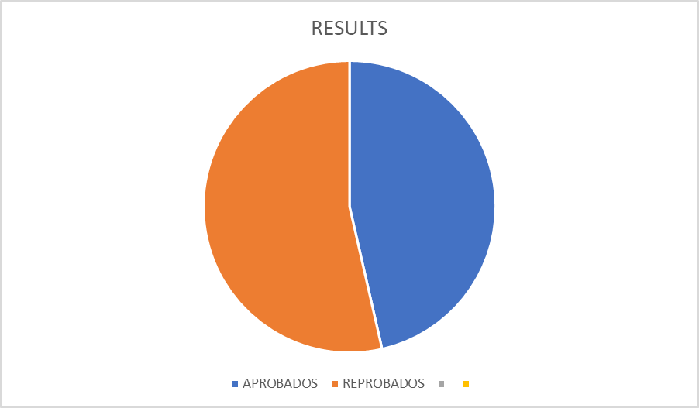Figure 6. Results diagnostic exam

2.2.2 Objectives
My main objective is that with the implementation of the methodology of presentation, practice and production making using of power point presentations and with that I hope to promote learning in the students of second grade of secondary school, as well as make use of this method exposed by various authors to mainly focus on the grammar of English.
In such I can get a lot of benefit since the class becomes the opposite of the traditional and this supported by the methodology allows me to keep track of the class and also the pace at which students are understanding the subject , with them the students will mainly show an interest in wanting to learn since they will be motivated through participation, recreational games in the classroom, teamwork, etc. and in this way they will be able to develop a learning process in each of them.

2.2.3 The group of study
The 2nd B group is one of the 5 groups that make up the second grade of the Alberto Isaac Ahumada Secondary School and has 29 students, 13 boys and 16 girls, some of whom were moved to another group for school reasons, in order to generate a positive change in the classroom.
The English subject is taught by Paola Favila Salas, who has 5 years of service in front of the second-grade groups. She has 3 second grade groups in which I also teach.
The second B classroom is located at the end of the second-grade hallway, in front of the laboratory which is not used and next to the school cafeteria.
It is quite spacious for the 29 students and space for the teacher, has a traditional blackboard with which you can make use of the markers, but also have a projector and there is the facility to connect the computer or speaker to make use of them during class, which is quite appropriate to new technologies as not many high schools have these resources, also mentioning that there is internet for teachers which allows extensive use of technological resources.
For the students there are individual benches that are not in the best conditions and are almost always missing and they have to go to other classrooms, for the teacher there is a desk and a chair that are in good condition, as well as the classroom that has several large windows and is always very clean, this is also because the students in this classroom are very clean and keep their space in order.
According to the learning channels test applied according to O'Brien (1990) "determines in which way it is easier for the person to receive the information and then process it".
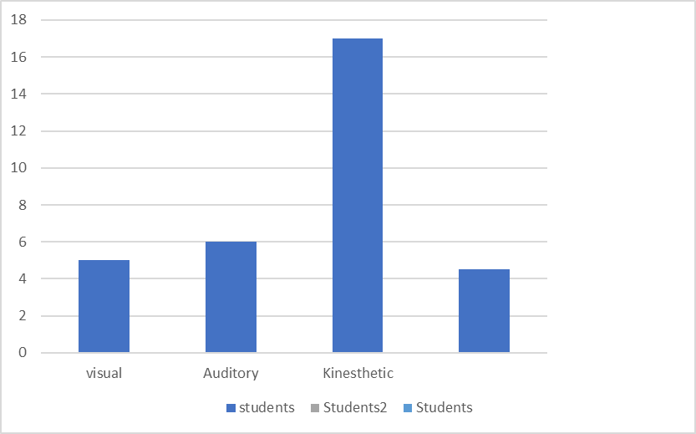
Figure 7. Learning Channel Test

According to the test applied, most of the students gave us the kinesthetic result, which means that they remember the actions they are learning in order to act accordingly with the different challenges they face, some students did not answer the test correctly and the rest turned out to be visual and auditory, with the majority of the group being kinesthetic learners.

2.2.4 Theoretical foundation
The topic on which I base my research is about the importance of teaching grammar applying it in Alberto Isaac Ahumada High School, based on my observations and previous tests (diagnosis and learning channels) which helped me to have real results of the level in which the students were, and also the way in which they learn.
The results shown in the aforementioned tests made it clear that the students had different factors that affected their learning of the English language: lack of motivation, absence of a teacher in front of the group, not having the subject previously, that is, many children did not take the English subject in their primary schools, when they entered the first year of secondary school they did not take the subject as such, so their knowledge was basically at zero, so I had a task, to get the students motivated and learn starting with the grammar part.
English is a universal language, being the most spoken language in the world, a language that opens doors to many opportunities and actually a very easy to learn language in which we can compare with other languages such as French or even Spanish that have many grammatical rules, terms and synonyms very varied.
In order to learn English, grammar is necessary “grammar is a description of the rules that govern how language’s sentence are formed” Thornbury (1999) because it is possible that without learning it, we can produce a communication in a second language, but we would be unable to complete ideas in real words, that is why I give importance to teach grammar to this second-grade class because they do not have any knowledge about this language.
As a practicing teacher, I believe that the teaching of grammar should be pedagogical, in order to give students, the basic elements that will help them understand the grammar of the English language and thus be able to master it, in this way we would promote a better method for learning English.
As English teachers we should look for ways in which the students can learn the language and not only give them the subject, that is to say that they acquire it, since many public schools have students who have never taken this subject in their education, so most of the time they arrive at the secondary level with zeroes, during my previous semesters I could observe this problem in the different secondary schools where I gave my practices.
We should start with the basics and take into account that they have a low level, for this the implementation of grammar will be the best tool.
Grammar" is considered a framework through which the rules and principles of the English language can be explained as concisely and clearly as possible for the benefit of ordinary learners. Pedagogical grammar is for teachers and learners of English. " Andrew Rossiter (2020). As a teacher we must be able to provide students with these different elements in order to transmit them and give them clues so that they can master and speak it, as Scott Thornbury says "grammar is a tool for making meaning" (1999).
in the schools of basic education at the secondary level, there are not many programs and activities that promote the learning of English, based on my experience during my stays in the different secondary schools where I did my internships in the previous semesters.
Base on the previous comments, teachers are the main responsible for generating a change within their classrooms, this leads me to choose the topic of "methodology of PPP to teach grammar in ESL classroom", since as a future teacher I want to teach English as a foreign language. As a future teacher, I wish to achieve a great change in my future students in order to provide them with the necessary tools and harvest in them a learning which will open many doors for their future life.
Based on this type of cases and of course on the lag and disinterest of the students, the methodology of presentation, practice and production for the teaching of grammar in the second language, where the teacher presents the language and gives the students the opportunity to practice it through diverse and controlled activities.
During my practice I will improve and innovate in each and every one of these aspects, for this with the support of my methodology and the resources that I will be using (power point presentations) and various activities that will help me to measure the level of learning of my students through reflective cycles.
The Smyth reflective cycle will help me measure my students' progress, John Smyth says that teachers are going to uncover the forces that inhibit and constrain them, they need to engage in four forms of action with respect to teaching.
These forms are characterized by four sequential stages and are linked to a series of questions:
a) Describing (what to do)
b) Informing (what does it means)
c) Confronting (how did I come to be like this)
d) Reconstructing (how might I do this differently?)
The reason why I chose this cycle as I mentioned before, first of all it talks about choosing a problem and analyzing how I am going to face it, in this case we talk about the lag and lack of motivation to learn English relating in this way its different stages and mentioning before how to act before this problem, going through the 4 stages mentioned by smith and measuring the development and progress by means of a qualitative analysis.

2.2.5 Action Plan
It is difficult to understand what quality of education means, for teachers is a very important role to develop as they are the main characters that help to establish the quality of education, there is a concern for the quality of education and its improvement "We live at the beginning of the third millennium, where the rapid social and technological changes require the construction of new images of both education and technology, and the construction of new images of education.
technological changes demand the construction of new images of both education and teachers.
of teachers" (Latorre, 2003, p.10). For the improvement of this phenomenon as a teacher in training, I made an action plan in which I included a set of strategies that will bring about a change in the students of basic education at the secondary level.
According to Latorre, the teacher puts into practice his action plan by first detecting a problem in order to seek through research-action a quality in the sense of education.
For Bartolomé (1986), action-research "is a reflexive process that dynamically links research, action and training, carried out by social science professionals, about their own practice.
For this research I have relied on observations, strategies, use of different methodologies and the support of theoretical authors, all this in order to apply a strategy to help improve the quality of education in secondary schools with emphasis on the subject of English.
For the application of the action plan different activities have been used, which will be based on the methodology Practice, Presentation and Production of Jeremy Harmer which will be used to teach grammar.
The action plan has been chosen to help measure the progress of the 2B students. For Latorre (2003) it is a process that is characterized by its cyclical character, which implies a "back and forth" -dialectic spiral- between action and reflection, so that both moments are integrated and complement each other. The process is flexible and interactive in all phases or steps of the cycle.
To carry out the action research using a reflective cycle, which is an alternative model to the teaching style in which the active involvement of students is sought through personal reflection and collaborative work, this is proposed by different authors, for this purpose, I selected Smith's reflective cycle, Smyth's Reflective Cycle (1991). The reflective cycle starts from a description and information of teaching practice at the classroom/department level, and once confronted with that of the teachers as a means of detecting and clarifying the daily patterns of teaching action, the process culminates in a phase of articulation and reconstruction of new and more adequate models of seeing and doing.
DESCRIPTION.
Reflection on practice begins by describing, through narrative texts, the critical events and incidents of teaching. Such means of description may be;
a. Diaries: contributes to reflect on what is happening during the week, collects observations, feelings, reflections, frustrations, concerns, interpretations, position taking, explaining hypotheses of change, comments taken from the day to day, from the concrete practice.
b. Narrative accounts and critical incidents: to construct a narrative is to recreate, represent or exemplify a situation, giving it a certain meaning, which forces to understand and reflect on the experience.
The description stage refers to writing down all the relevant aspects that occurred during the teaching process. In this case, during the observation stage, the field diary was used to record all the things that were observed in class from the very beginning.
EXPLANATION
It is necessary to make explicit the principles that inform or inspire what is done, which implies elaborating a certain theory and discovering the deep reasons that underlie and justify the actions, where the reconstruction of practice can generate new understandings of oneself, of the teaching situations and of one's own implicit assumptions, and thus generate a possible trajectory of change and improvement.
For a cognitive reconstruction to lead to congruent actions, it must focus on the "theories of use": focus on the stated theories or arguments that justify what is done and why it is important.
CONFRONTATION.
In this case, it is a matter of questioning what is done, situating oneself in a biographical, cultural, social or political context that gives an account of why these teaching practices are used in the classroom. Smyth (1991:285): "Seen in this way, teaching ceases to be an isolated set of technical procedures and becomes a historical expression of values constructed on what is considered important in the act of education" (Smyth 1991: 285).
a) analysis and action
b) analysis and understanding
c) more general contexts
RECONSTRUCTION.
It is a process by which teachers, immersed in their reflective cycle, restructure their vision of the situation, personally and collegially elaborate more defensible frameworks of meaning and action, and thus try to guide and improve their own teaching and their students' learning.
Improvement proposal:
In order to achieve and reach an improvement in the 2B classroom we proposed the application of different activities taking into account, in this type of strategies where my purpose is to achieve meaningful learning in students.
The application of these activities will be presented through the use of technological resources such as the computer and the projector, through this will be the use of power point presentations where the grammatical themes will be explained, keeping a record of them in the field diary and activities carried out in the classroom.
In the 2B classroom, 2 reflective cycles were carried out, one in February and the other in March, for this purpose, a record was kept in the schedule of activities, as well as notes in the field diary and therefore the evaluation of these activities applied.
Figure 8. Action Plan
During the month of February, we worked with the grammatical theme "Simple present", in which different activities were applied.
Topic | Activity | How did it work?
Simple present | Students were presented with a diagnostic test to measure their knowledge of the "present simple", the test assessed their understanding prior to the explanation of the topic. | The results showed that the students did not have a concrete knowledge of the subject, however they were able to answer some sentences, the total number of correct answers was 10 and most of them got 6 to 7, which was good.
Simple Present | By means of a power point presentation we introduced the topic "simple present" making reference to its use and examples with sentences, we started the practice by means of participations on the whiteboard where the students completed sentences, once they understood the topic we assigned them the activity which was about jumbled sentences that the students should put in order according to their structure. | The progress of the students was excellent, they understood the topic very quickly and it was easy for them to use it in sentences, it worked very well.
Simple Present “Dictation” | The main objective was for the students to acquire the vocabulary of the present simple, for which they were given a dictation using sentences.  About 10 sentences with the structure of the present simple. | The students find it difficult to write words, I could notice that their sentences were not well written but they all made an attempt to write.  Regarding to the structure they did very well
Simple Present (Flashcards) | By means of presentation the students were introduced to some activities about present simple topic, this time used in different context, making use of different verbs and subjects, they began to practice by asking the students to participate in forming sentences and for the activity by means of flashcards the students began to form sentences in a group way, it was a very Dynamic activity. | This activity allowed me to measure the level of learning that the students had of the topic, since it was to form sentences and at the same time to express themselves, thus implementing the speaking too.
Simple Present ( Game ) | The practice of the vocabulary acquired during the sessions regarding the topic of present simple was practiced through the game of the scrambled basket, in this case the students were given flashcards with verbs, through this activity they practiced learning about verbs and their structure in the present simple, it was an activity that kept the students very amused and i was able to achieve their learning through this game. | Creative and Dynamic activity where the students participated enthusiastically, with the exception of some of them because the game was fast and they got nervous and forgot it, even that was an excellent activity.
Figure 9 Results of the action plan
In this first cycle the grammatical theme that was handled was the simple present, in the form of sentences and the activities were carried out individually, we began by introducing a diagnostic test where the previous knowledge was measured before the introduction of the topic, which yielded a result at a not so high level, However, they had an idea of what it was about, throughout 5 sessions (without taking into account the quarterly evaluation) were applying various activities focused on the same topic, the result was satisfactory and of great impact since I could notice that the students understood the topic very well, the expected learning was achieved.
Expected learning cycle 1: The student is able to understand and recognize the simple present tense and make use of it through sentences in his notebook.
EVALUATION REFLECTIVE CYCLE (1)
For the evaluation of the first reflective cycle, tools were used such as the registration list where each student's activity and participation were recorded, the diary was also necessary to check if the activity worked or not and to make adjustments, if necessary, small quizzes were applied that were not included in their qualification but as extra points, it is worth mentioning that all these activities were applied individually.
Figure 10. Reflection cycle 1
Figure 12. Action Plan II
For the month of March we worked with the grammatical theme of "Have to / Has to" making use of this to express obligations within the school, finally we had to modify the planning and add the theme of cultures and traditions of English speaking countries where a previous vocabulary was introduced to make use of it, 6 sessions were used to apply the cycle number 2, however only 4 of them were "effective" fulfilling the planned activities and time criteria, for other reasons (school events) the other 2 activities were not taken as planned.
Topic | Activity | How did it work?
Has to / Have to | By means of a presentation, the teacher introduces the topic, giving examples with sentences and student participation on the whiteboard, practice is given and its use is mentioned.  The students make notes in their notebook as well as grammatical structure, they make simple sentences. | It worked very well, although at the beginning they were a bit confused, but through practice and structure they were able to make some simple sentences on their own.
Has to / Have to (Group activities) | For this activity the students worked together and with the help of flashcards representing the scrambled sentences, the students had to order them, following the correct order of the structure as well as the use of each auxiliary. | The activity worked well, although some teams were a little confused by the structure and use of the auxiliary, they were guided and given examples to take it from there, the time was well distributed and the students learned very well.
Cultures and traditions of other countries (Activities) | For this activity, a power point presentation was made where the topic to be worked on was presented, taking into account the previous vocabulary (the students took notes). During the activity they made a comparative table of the different cultures. | During this activity they were able to show their interest in these topics that are not commonly seen, and entertaining and somewhat innovative because in this case photographs were added that motivated the students and could capture their attention throughout the class.
Cultures and traditions of other countries (Exposition) | According to the information obtained, the students were given a different country of which they had to make a presentation in a collaborative manner in which they expressed the characteristics of each country, implementing their ability to speak. | It was a little difficult for the students to voluntarily want to speak but in this case, they were very creative with their presentation and the content was in line with what was asked of them, in the case of speaking few showed their ability.  was recognized with a extra point for best team
Figure 12. Results Cycle 2

EVALUATION REFLECTIVE CYCLE (2)
For the evaluation of cycle 2 i used the notes on the attendance list , the observations on the dairy and the activities on the notebook , In this cycle, two themes were implemented and another change that was added was teamwork, which proved to be very effective.
Figure 13. Evaluation cycle 2

2.2.6 Observations and Evaluation
For the evaluation of the different activities that were implemented, an attendance list was used, the attendance list directly related to the learning of the students, as well as the coexistence with their classmates and the experiences that are generated on a daily basis in the classroom; a list in which the delivery activities, attendance, extra tenths acquired by the effort and also the failure to comply with them were recorded, in order to keep a record of each of the students.
Figure 14. Evaluation List
The field diary:
The field diary is a technique that, through the creation of annotations, serves as a support to memory, stimulating the recreation of experiences, leading the writer to reflection and self-criticism through a Catharic process, and is important in the formative process, as it gives an account of personal opinions, frustrations and achievements of the writer (Sanjek,1990). Nevertheless, for me is an instrument that I have used throughout my internships and it serves me to record day by day the observations, in this case of my study group I write the class and reflect on what function? What did not work? what was the reason? and with that what can I implement in the next class.
Photographs:
“Photography allows us to observe, analyze and theorize their social reality, more specifically the image as data helps to observed and makes it possible to Delve into aspects that are less visible in other ways of recording what is observed” (Bonetto,2016)
During different sessions I was taking pictures as proof of the progress of the students during the different sessions, these would help me to show that they were making progress, in the photos taken, students were not allowed to show their faces, as part of the students’ privacy because the focus was on what they were working on at the time class.
Lesson Plan:
Ruiz F, Beatriz (2019) Didactic planning is the tool that allows the teacher to organize thought and action, order the task, stimulate sharing, confrontation, help to establish priorities, to become aware of what he/she is going to teach, on the distribution of time.
Didactic planning, which is the main tool where the activities, times and evaluation tools that will be used throughout a period are reflected.
I carried out this planning for 2 months, in which the learning development processes were taken into account, the expected learning, the activities to be carried out in each session, the measure including each of the topics included.

Figure 15. Lesson Plan

The planning format suggested by the school was followed, but it did not affect the application of the contents, taking into account that the format must comply with the requirements of the new Mexican school.
For the development and learning processes suggested by the SEP established in the new plan and program of study for preschool, primary and secondary education 2022, offering elements to teachers to strengthen analytical programs and their didactic planning.
In this case, the activities planned and established for the students were followed, being so all that was applied during the month of February and March.

2.2.7 Reflection
In the first reflective cycle I tried to implement for the first time the methodology of presentation, practice and production to teach grammar, so based on the previous observation in my field diary I was taking several notes about the students and their way of learning, from there I started planning my activities.
The group was very heavy, there was a lot of disorder, they did not pay attention, and showed too much lack of interest to the class, the students did not fulfill the activities that were implemented and, in some cases, did not even bring their material for class, because of this they began to impart severe punishments such as taking away the permission to go to the cafeteria, extra tasks, lower points and therefore I started with the same dynamics.
It is important to attribute to the students the importance of school because here they are formed as human beings and too many opportunities are opened for their future life by it seeks the achievement of meaningful learning in students which is that learning that guides the creation of knowledge structures through the substantive relationship between new information and previous ideas of students. Diaz Barriga (2004).
In the school context, it is important to point out that it is a low-income school and its surroundings contribute to the fact that this directly affects student learning.
From the motivation that is generated in the students with the strategies applied during the 6 sessions, it is expected to achieve in this way their learning, evaluating it in a formative way.
For formative evaluation: a process in continuous change, product of the students' actions and of the pedagogical proposals promoted by the teacher (Díaz Barriga, 2002, p. 23). In cycle 1, formative evaluation was carried out by means of: Rubric, Posters, Presentations, Exhibitions and Notes as well as a Quiz that was done prior to their knowledge of the subject.
In the Quiz a dictation of 15 verbs which the students had to write in Spanish was carried out, the results were favorable since most of the students obtained good results.

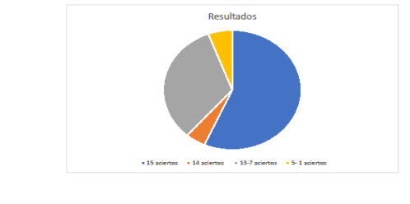 Figure 16. Results of quiz application
We started from here to begin with the other activities, which were implemented with the same technology and making use of the technological resources.
ACTIVITY 1 | ACTIVITY 2 | ACTIVITY 3
19/27 | 22/27 | 27/27

As can be observed during the first three activities of the cycle, the students were increasing the delivery of activities, this favored their qualification, contributing in this way to their learning, since the activities were carried out on an individual basis.
The reasons why the students did not deliver the activities were the following: the students did not attend classes for personal reasons which are not within my reach to solve, the students did not understand the activity which was a limitation to be able to perform it.
ACTIVITY 4 | ACTIVITY 5 | ACTIVITY 6
27/27 | 27/27 | 25/27

During the activities applied in the second cycle, it was possible to notice the progress of the students, they worked very hard on their work and began to be recognized by assigning them extra tenths.
ACTIVITY 7 | ACTIVITY 8 | ACTIVITY 9
27/27 | 25/27 | 27/27

During cycle 2, group activities were applied, including the use of flashcards, and exhibitions were also implemented using the English language and encouraging speaking, most of the students complied with the activities except for some of them who were absent during those sessions, and some of them did not attend.
ACTIVITY 10 | ACTIVITY 11
26/27 | 27/27

The students responded better to these implemented dynamics, they were more integrated and there was a lot of participation, which was reflected in their grades.
During these periods, two exams were administered which evaluated the topics seen during the months of February and March. It is worth noting that there was a noticeable change, the average of the group as a whole went up 0.3 decimal points but we can notice that students with failing grades increased.
This was the final result, it can be said that the cycle was useful as well as the dynamics implemented, it was a total success, the students show their interest in the class, it can be said that the methodology used was effective.

CHAPTER 3
Theorization, conclusions and recommendations

3.1 Theorization
When is talking about to language teaching, a great deal of research has been done by linguists around the world and many theories and methods have been proposed for how languages are best learned. During my career I have investigated about different strategies which the English teachers apply in their everyday classes and I have had the opportunity to know various methods in the process of practice.
However, as a result of the observations of the context and the characteristics of my students, I will decide to use the Presenting- Practice –Production methodology. Among many methods, the PPP is widely used throughout the world by many English teachers as a Foreign Language (EFL). This report contains several strategies based on the PPP methodology. Some authors as Jeremy Harmer research about it to teach English.
According to Jeremy Harmer (2009), the PPP is widely used for teaching certain kinds of languages at lower levels, for my practice I took into account that my students had a very low level of English, so I saw the method as viable.
Harmer tells us about the 3 steps to be followed in the methodology:
1. Presentation: The teacher introduces a situation which contextualizes the language to be taught, then the language is presented.
2. Practice: The students practice the language, using accurate reproduction techniques such as choral repetition and individual (phrase or sentence)
3. Production: in this phase the students use the new language to make sentences of their own.
Many of the authors who talk to us about this methodology provide important information in teaching English. For example, Scott Thornbury (1999), mention that PPP allows the teacher to control the content and pace of the lesson, which for new teachers in particular helps them cope with the unpredictability of classroom life, however he said that all learners go through a long stage of making mistakes.
The PPP represents an accuracy – to fluency model of instruction divided in also three steps:
• The learning cycle begins with the meanings that the learners want to convey
• Express these meaning using their available resources (guidance as to know to do this better)
• Include explicit grammar instruction (through successive stages of trial, error and feedback) the learner’s output is fine turned for accuracy
Scott's model talks about achieving fluency through error correction and feedback. However, the students in my study group were focused to form sentences and understand grammatical issues. These results were seen at the time of the evaluation and presented in the conclusions.
Several authors mention the advantages and disadvantages of the application of this methodology in teaching English as a foreign language. Below I explain the advantages and disadvantages that I had at the time of applying the PPP methodology in my study group.
The model proposed by Harmer has its advantages and disadvantages that I had during the application of it. One of its major benefits is that it is flexible for the topic to be taught, since the teacher is the one who will be in charge of making the corresponding changes if needed, adapting it in this way to the context, the needs of the students and the production. How is it going to work? What will the students be able to do without help? It ranges from phrases to sentences. Sometimes I adapted games such as scramble basket, bingo, or competition games in the practice part and in this way the students had fun and learned.
Another of its benefits is that it can be presented in different ways, by means of videos, presentations, lectures, etc. In my case I used power point presentations because I had a projector and internet in the classroom, so I saw the advantage of the flexibility that I had, I only adapted it depending on the grammatical topic to be presented.
On the other hand, disadvantage of the method is that only works with low level students because the activities are controlled by the teacher and students who has a higher level can skip all the steps and go straight to the production stage. So, it is better to know well what is the level of students.
Another disadvantage that I found was the time given to the students in the practical part. If we give the students a little time to understand the subject, they will probably find it difficult to produce it by themselves and in this case several examples would be needed to make it clear.
Once applied my strategy to promote the learning of grammar supported by Jeremy Harmer's presentation, practice and production methodology that I realized on the second-grade group B in the Alberto Isaac Ahumada High School the results obtained were very Good.
Initially, the study group of the school year had a very low level of English and progressively they were having a significant advance based on the methodology applied. A great tool was also used to reinforce the presentation phase. I mean the use of the technological material through the power point presentations where we tried to implement in this way the presentation of all the topics seen.
Through games and different activities, we were looking for ways to attract their attention to the subject, as the activities were changing the students were showing their interest in English as well as their performance in the delivery of activities, teamwork, especially their active participation, in a short time the students increased their average significantly.
Harmer's model allowed me to have total control of the sessions applied, which I adapted to their needs.
As mentioned above about the phases of the PPP methodology, (Harmer 1999) During the application of the methodology in my practice, according to the characteristics of my research group, I started with the presentation of the topic explaining in a general way, through power point presentations. Several studies tell us that the use of technology is a very good tool for learning English: Hughes (2005) states that this technology produces positive effects on the brain's process of language acquisition, so students tend to improve their learning, a tool that should be taken into account for acquired, English is constantly changing and it is a good resource for learning English.
In the second practice stage, in this part, during my practice we practice with examples through games and different activities. Here the students practice the topic already presented the scrambled basket, Competition games and Bingo were some activities applied. Sometimes I implemented the sentences as practice, we did them in groups to achieve their comprehension and then the students practiced them individually. Always looking for ways to attract their attention to the subject.
Finally, in the production stage I applied different activities in that stage like worksheets, team presentations, activities in the notebook related to grammar topics and also posters that the students made with the topic already learned.
Without a doubt, I obtained a good response from the group because they were able to perform these activities themselves, they were corrected sometimes and given support for explanations but giving the opportunity to express what they had learned.
One of the most remarkable things that the students were able to achieve was the formation of sentences using grammar. One of the main objectives I considered was to give importance to it, since as Thornbury says “grammar is a tool for making meaning” (1999). Once we have mastered the grammar, it will be easier to learn the language, even if we don’t know how to speak it, but we understand its structure and the meaning of the words. The students were able to understand grammatical topics, which is a great advantage for them.
For the analysis of the reflective cycles in the action research methodology proposed by the tower, we used Smith's cycle, which suggests 4 steps to achieve the analysis of the cycles:
These forms are characterized by four sequential stages and are linked to a series of questions:
A. Describing (what to do)
B. Informing (what does it means)
C. Confronting (how did I come to be like this)
D. Reconstructing (how might I do this differently?)
As I mentioned before in chapter 2, the cycle was useful to me because it talks about detecting a problem, analyzing it and seeing how to face it by going through the stages it mentions. After detecting the problem, I had in front of the group, I was able to make a lot of progress in finding a way to solve it. I faced some problems but I still reconstructed my plan to achieve the expected, it can be very well adjusted to this type of methodology since we are making adjustments to improve.
In summary, the students gave a positive response to the methodology applied, they increased their grades remarkably and through the different activities proposed a change was taking place. The students were able to improve their grammar, helping also to develop speaking skills in which they performed not in the same way. From the beginning of this research the objective was to help the students to improve their level and the strategy was totally adequate for them due to their low level of English.

3.2 Conclusions
Throughout my professional practice training I have managed to develop various skills and improve my professional and disciplinary competences that favor my professional field. Definitely my professional practices were a significant watershed in my development as a teacher in training, I learned from myself and especially from my students.
My skills and competencies acquired during my degree allowed me to use of my knowledge of the English language to transmit it to the students, taking into account the level of English they had. That helped me to start from the topics that needed to be learnt. In other words, I adapted my lesson plans according to their needs. Talking about my disciplinary competencies, I improved my teaching by using various activities and games that will help second grade students optimize their knowledge.
The group's observation and analysis showed the general objective of this report, which is to improve the learning of English grammar through the PPP methodology in second grade students in the English as a second language classroom. To achieve this, activities and strategies were used that were adapted to the characteristics observed in the second-grade students. Each of the strategies used applied during the internship period supported the achievement of this objective and the completion of the report, as well as the strengthening of my skills.
It should be noted that I felt very proud and happy with the response of the students. It was very good, the classes began to be more fun, therefore their participation was encouraged, it is worth mentioning that the students received extra tenths for their effort and this was reflected in their grades.
However, it was not an easy task because it was full of intense work since one of the disadvantages that I had was the interruption of classes due to holidays. That situation did not allow me to carried out my activities according to my planning and therefore I had to change activities and even eliminate them. Another problem was that the students were absent, so they lost some activities and classes after that, was complicated to explained them again. Also, some students were changed of groups for personal problems, so, I had to adapt to those changes.
During the first cycle I made my presentations full of information and I focused a lot on the formation of sentences on grammatical topics and I saw that the students took notes but it was very difficult for them. It was tedious to transfer the entire text in their notebook, so, to improve my presentations. I began to design my presentations including keywords about the topic and I focused more on repetitive examples, that helped the students practice was not tedious and became more dynamic. I could notice that there was a better understanding of the topic.
One of the new things that I implemented in the second cycle was the more dynamic activities, trying to include team activities and presentations and not just individual ones or writing sentences, the latter gave me very good results.
Likewise, the form of evaluation was very important, since it allowed us to identify the weaknesses and strengths that were presented in the classes and thus try to improve them.
During the development, different evaluations were used, such as the diagnosis that allows us to know the students' knowledge before to apply the methodology. Also, during the process some quizzes were applied to evaluate the students understanding about the topics seen. These evaluation tools were very good to obtain the results, which were very good and there was a reinforcement in their knowledge of grammar.
Another thing that I tried to support within the study group was group work. This strategy favors the social skills of each person as well as promotes team learning. Remember that learning to work collectively, mainly at this level, helps in student learning. At first it was difficult to try to integrate them into team activities but eventually the students learned to work in this way, they even made oral presentations thus encouraging speaking.
Finally, after applying the methodology and get the results, significant changes were observed in the students’ grades; they improved their self-confidence by participating in class, working as a team. Not only enhance their level of English but also their participation in front of the group.
To sum up, as far as the strategies applied and the results obtained are concerned, it is pleasing to know that the responses were positive, therefore the methodology applied was a success.

3.3 Recommendations
Based on the application of this methodology, I would recommend to use it especially with groups of low or medium level of English language. It should also encourage the students to get motivated. Other recommendation is to make a previous observation of the group, make a diagnosis of learning channels to understand which is the best way for most of the students to learn.
It is worth mentioning that this method, it is useful because help the teacher in a funny way to teach and learn by the student. We should look for ways to innovate and improve the traditional teaching model. The teacher is the main responsible for generating this change, he or she can support the student to enjoy English learning and have fun.
In the previous semesters when I was practicing, I could notice that many English teachers do not put into practice the language. A final suggestion would be to expose students as much as possible to the English language, so that they will have direct contact with the language and can improve significantly.

References

- HARMER, Jeremy (2009) How to Teach. 5th ed. Harlow. Longman.
- Scott Thornbury, (1999) How to teach grammar, P.128
- Krashen, (1981) Second Language Acquisition, P.19
- Conquist and Fiszbein (2017) El aprendizaje del inglés en América Latina, p.9
- Piñero and Flores (2018) A reflection on a professional Problem in the context of teacher education, p.243
- Harmer, (1998) How to teach grammar, p.12
- Bui, T. L. D., & Newton, J. (2021). PPP in action. Language Teaching for Young Learners, 3(1), 93-116. https://doi.org/10.1075/ltyl.19015.bui
- Johnson, (1982) Popular Methodology, p.11
- Harmer, (2001) A Critical Look at the Presentation, Practice, Production (PPP) Approach: Challenges and Promises for ELT, p.86
- Thornbury, (1999) How to teach vocabulary
- Byrne, (1986) 31 A Critical Look at the Presentation, Practice, Production (PPP) Approach: Challenges and Promises for ELT
- Anderson, L., & Burns, R, (1989) Research in classrooms: The study of teachers, teaching, and instruction. Oxford: Pergamon Press.
- Byrne, D, (1986) Teaching oral English. Harlow: Longman.
- Harmer, (1999) The practice of English Language Teaching, p.64
- Alatorre (2003) La investigación-acción Conocer y Cambiar la Practica Educativa, P.23
- Ausubel, D. P. (1963). The psychology of meaningful verbal learning. Grune & Stratton.
- Penny Ur, (1988) Teachers Grammar Practice Activities: A Practical Guide for Teachers. Cambridge Handbooks for Language
- Bartolomé, (1986) La investigación Cooperativa, P.56
- García, S., Baquero, O., & Castro, N. (2018). Learning a Foreign Language in the Formation of Higher Professional Education International Congress on the Didactics of the English Language Journal, p.3
- Ortiz, (2013) Learning a Foreign Language in the Formation of Higher Professional Education
- O’Brien, (1990) Behavioral Theory, p.3
- Thornbury, (1999) How to teach Grammar, p.14
- Latorre, (2003) La investigación Acción Conocer y Cambiar la Practica Educativa, p.10
- Bartolomé, (1986) La investigación Cooperativa, p.54
- Smyth’s model of reflection. (2021, 29 mayo). John Dabell. https://johndabell.com/2018/08/12/models-of-reflection-2/
- Sanjek, (1990) De las notas de campo a la teoría. Descubrimiento y redefinición de nagual en los registros chiapanecos de Esther Hermitte* p.77
- Beatriz, (2019) Planificación Didáctica, p.5
- Latorre, A. (2005). Investigación - Acción. Conocer y cambiar la práctica educativa. Grao.
- Lineamientos para organizar el proceso de titulación. Plan de estudios 2018. SEP SEP (2018).
- Orientaciones académicas para la elaboración del trabajo de titulación. Plan de estudios 2018. SEP SEP

Annexes

Appendix A : Learning Channels Test Appendix B : Results of the diagnostic 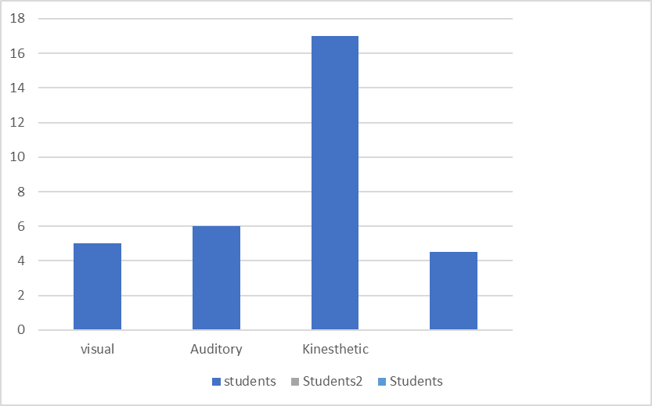

Appendix C: Presentations Cycle 1 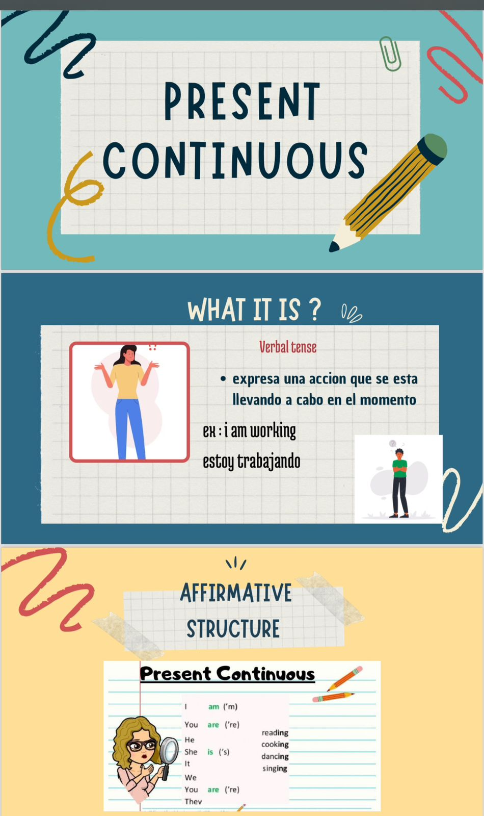
Appendix D: Presentation cycle 2 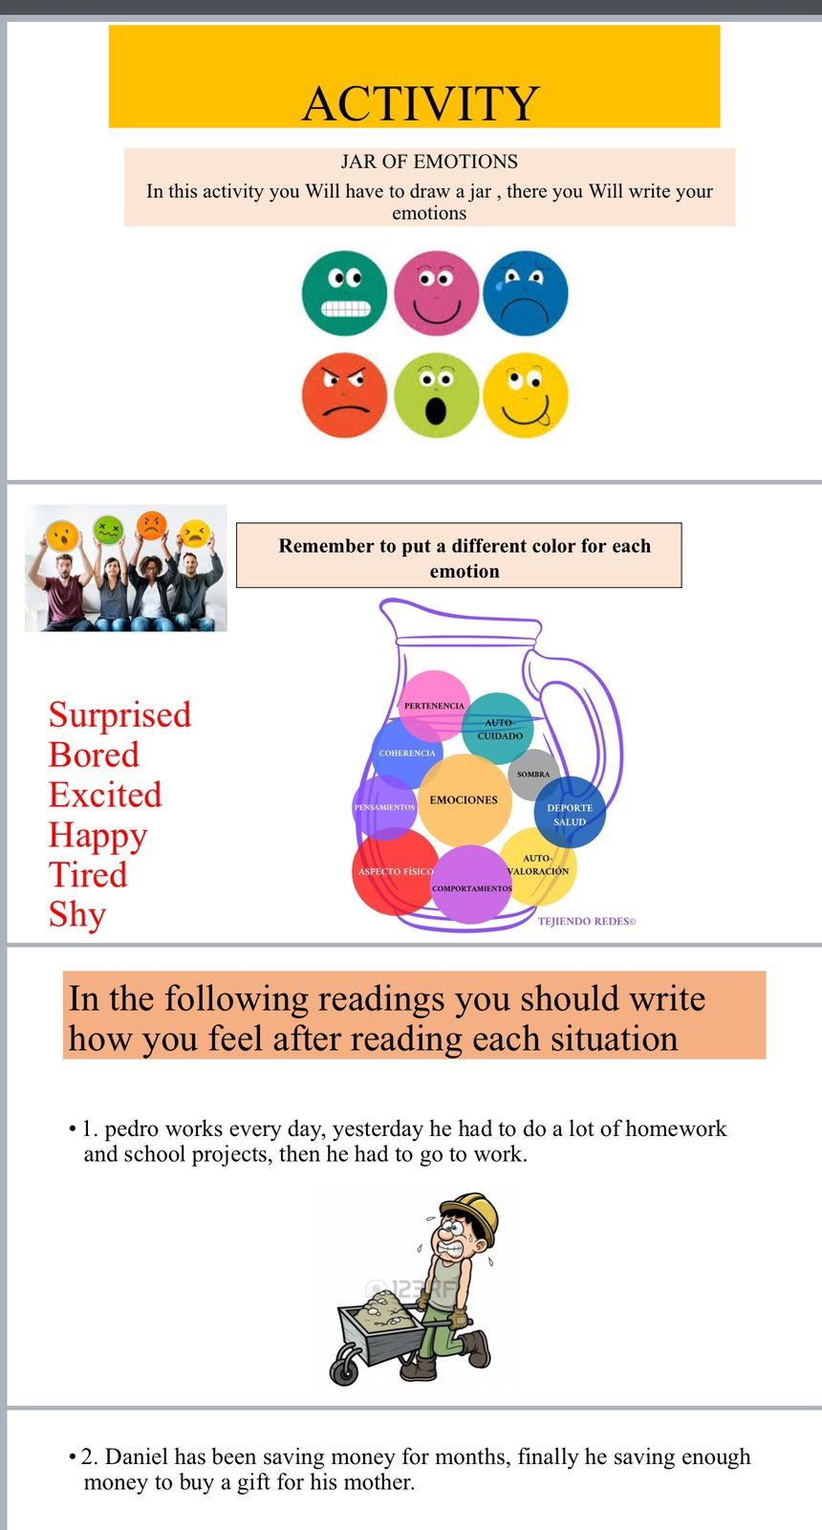
Appendix E: Presentation cycle 2
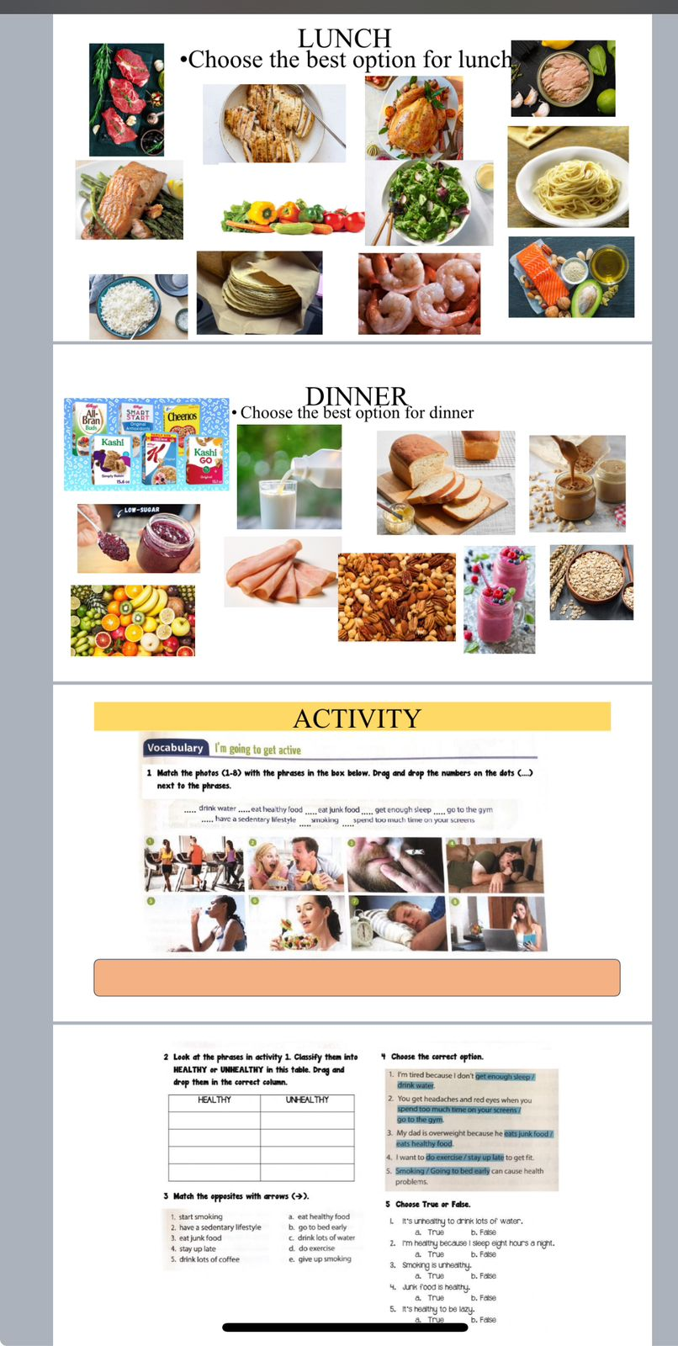

Appendix F: Presentation cycle 1
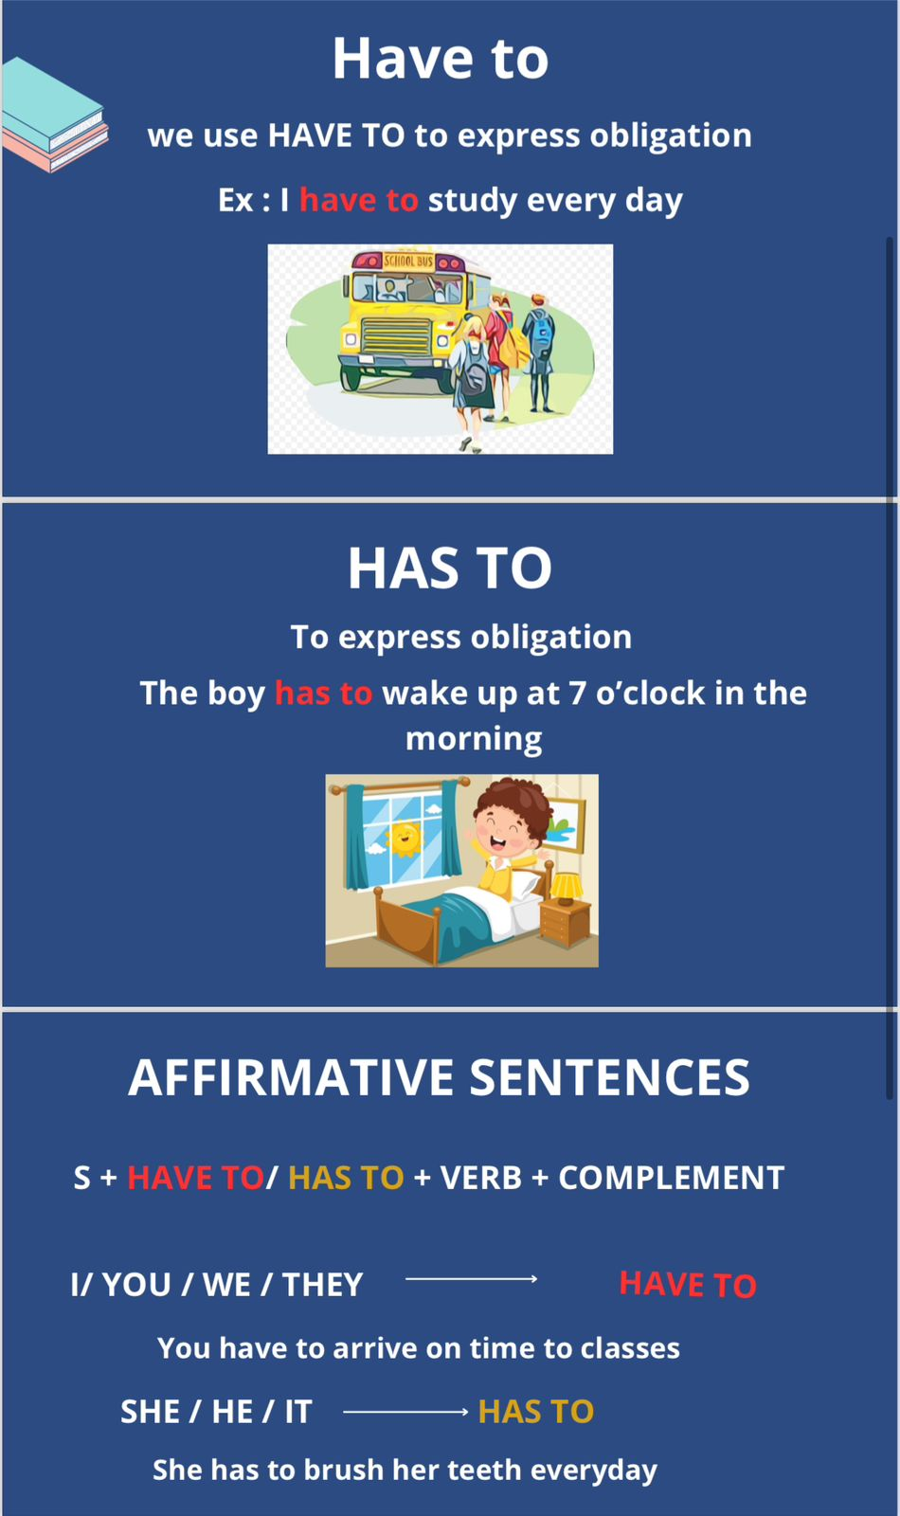

Appendix G: Evidences of the activities
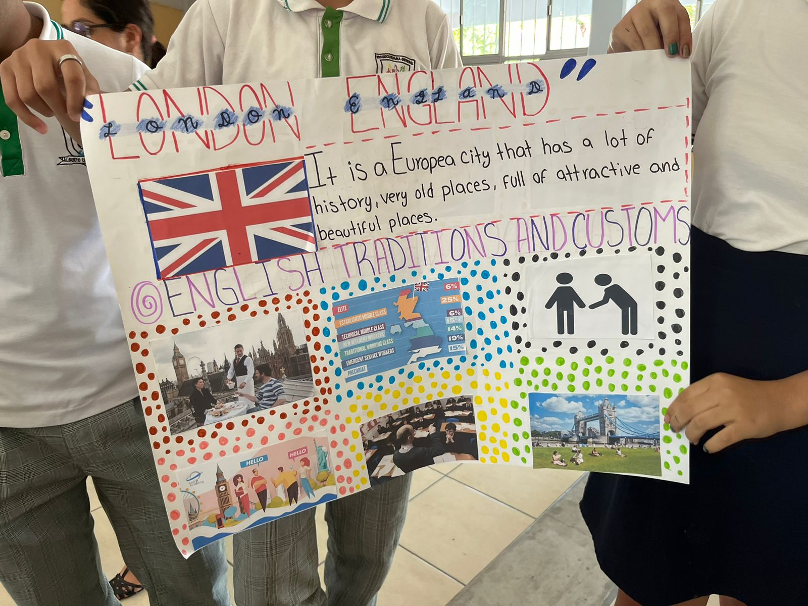Appendix H: Students doing the activity 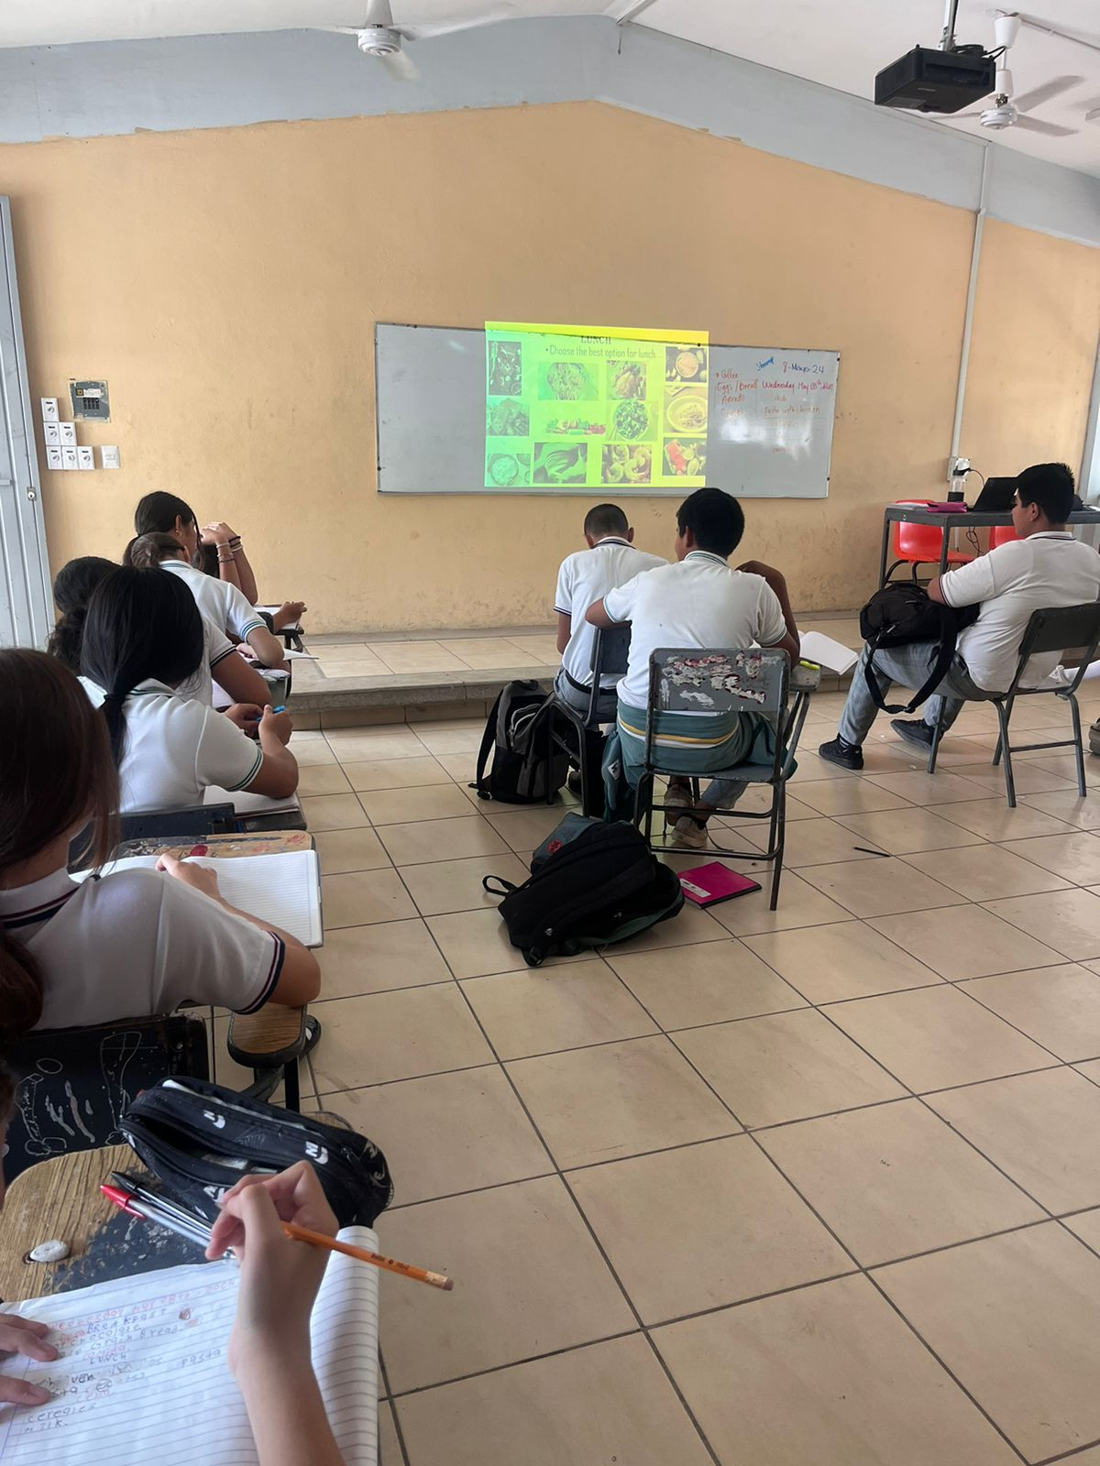
Annex I : Team activity
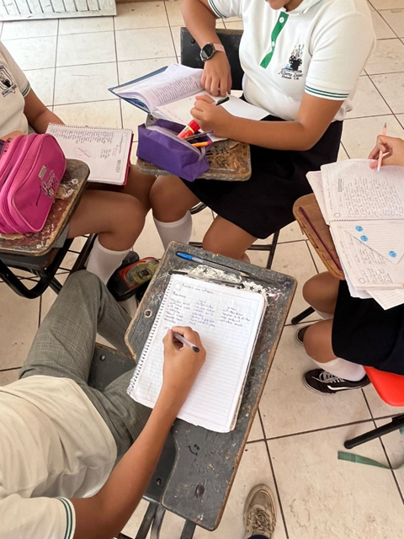

Annex J: Team work 